***WEB SCRAPPING PROJECT ON ALIEXPRESSS***

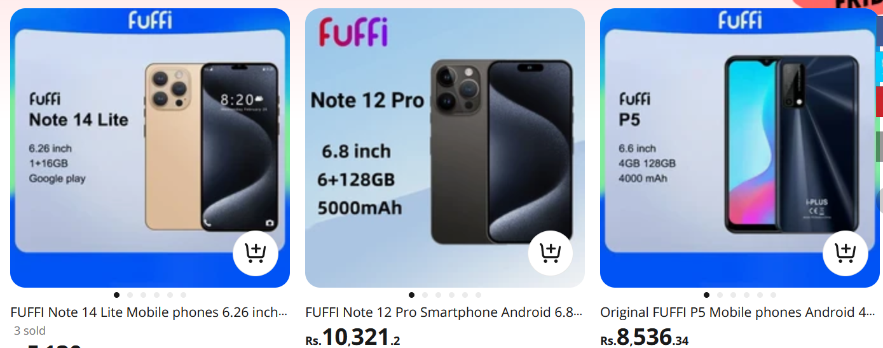

**DESCRIPTIONS:**

The AliExpress Smartphone Data Scraper is a web scraping project aimed at extracting valuable information about smartphones available on the AliExpress e-commerce platform. The project focuses on collecting data such as description of smartphones, pricing to create a comprehensive dataset for analysis and comparison.

**OUTLINE:**

From this site, we are going to grab the following information:

* Description
* Price

**STEPS:**

**Choose the Website and Webpage URL**

The first step is to select the website you want to scrape. We will try to extract data of smartphones from the website.

**Inspect the website**

Now the next step is to understand the website structure. Understand what the attributes of the elements that are of your interest are. Right click on the website to select “Inspect”. This will open HTML code. Use the inspector tool to see the class name of all the elements to use in the code.

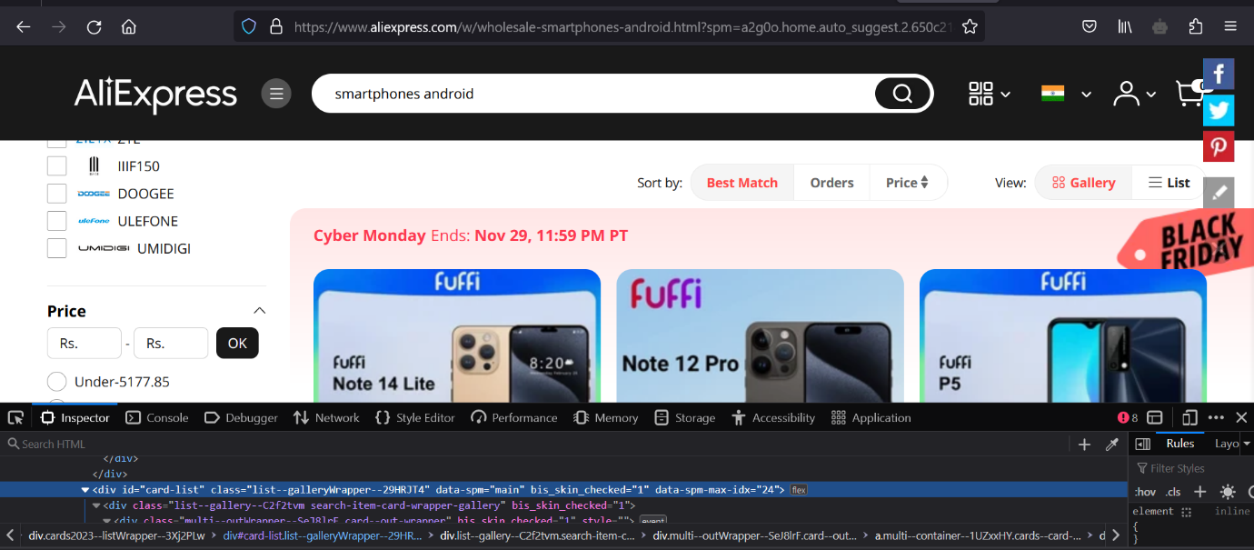

**Installing the important libraries**

Python has several web scrapping libraries. We will use the following libraries:

* **Requests** – for making HTTP requests to website
* **BeautifulSoup** – for parsing the HTML code
* **Pandas** – for storing the scraped data in data frame

**Write the Python source code**

We’ll write the main python code. The code will perform the following steps:

* Using requests to send an HTTP GET requests
* Using BeautifulSoup to parse the HTML code
* Extracting the required data from the HTML code
* Store the information in a pandas dataframe

**Exporting the extracted data**

We’ll export the data as a CSV file. We will use the pandas library. We’ll use the pandas library.

**BENEFITS:**

* Access to valuable data for analysis or research.
* Automation of data collection, saving time and effort.
* Stay up to date with change changes on the target websites.

**RISK:**

* Legal issues related to web scraping.
* Technical challenges due to website changes

**AliExpress Smartphones Web Scrapping Coding:**

1. Access AliExpress website by using import requests URL and BeautifulSoup library.

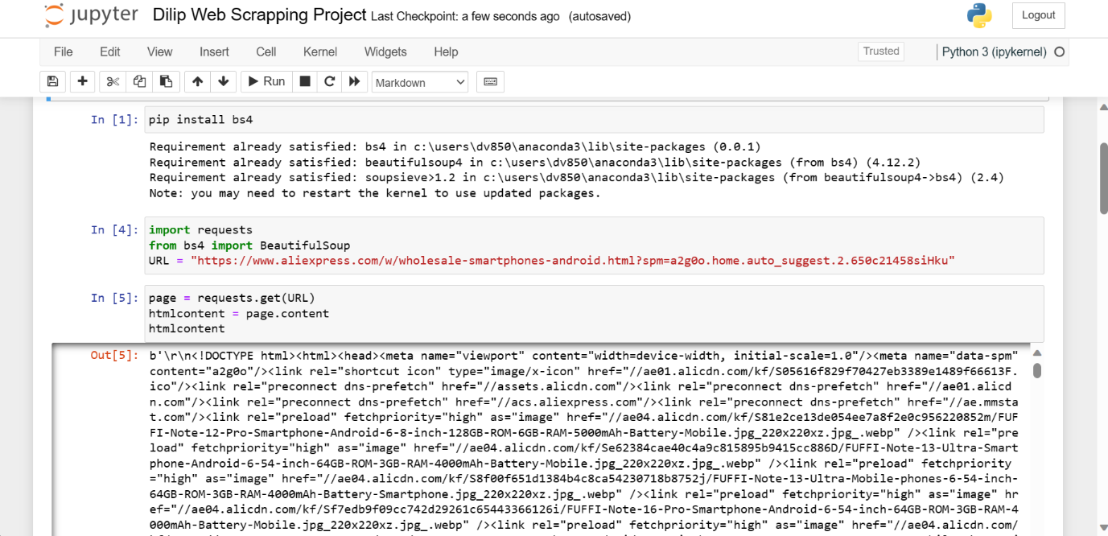

2. Parse the HTML:

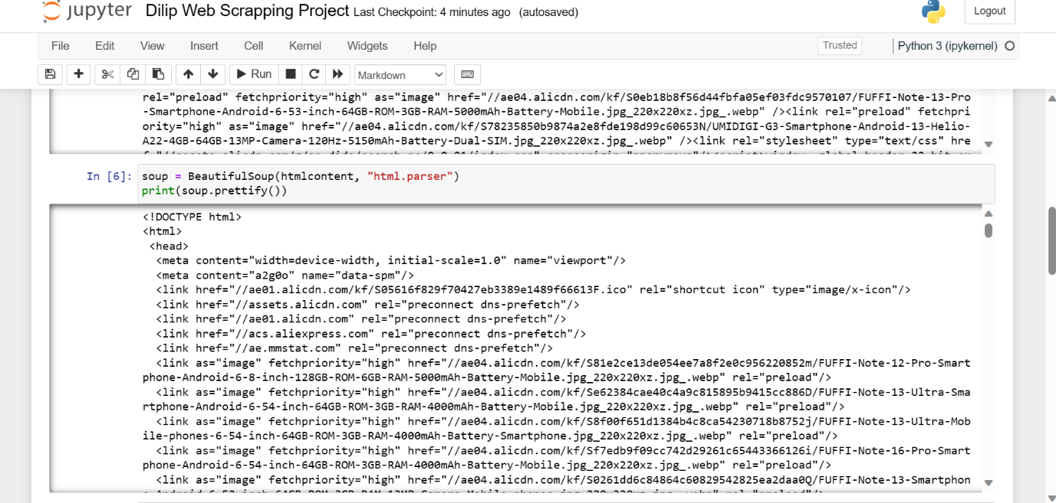

1. Access AliExpress smartphones description and price using this source code.

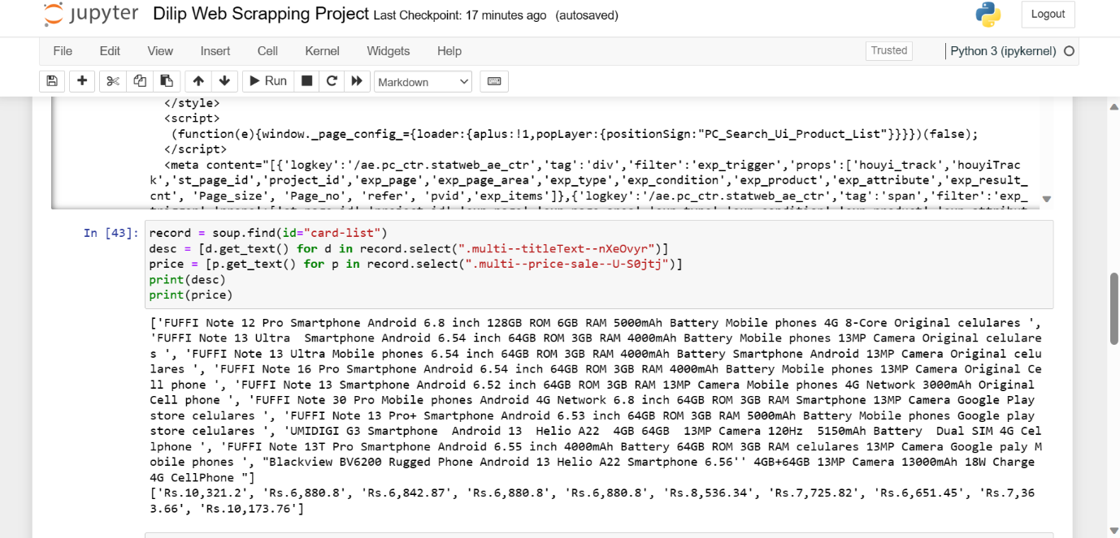

1. Arrange all the data using import pandas library.

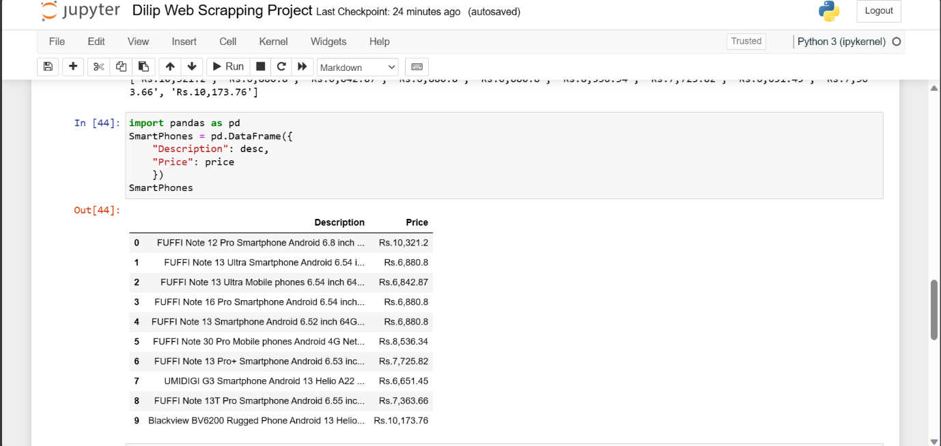

1. Store above all data in CSV file and again open this file in application.

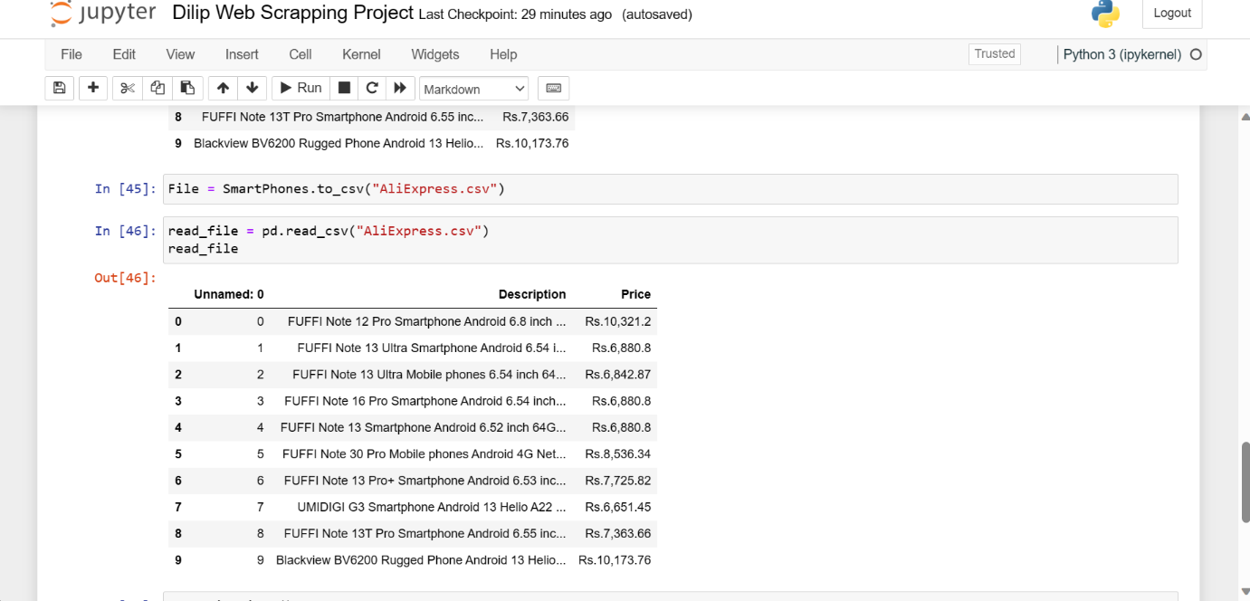

**CONCLUSION:**

By doing the project we conclude that the data can then be easily read back into a DataFrame for further analysis or use in other data-related tasks. This type of workflow is commonly used for collecting and analyzing data from websites or external sources.

